Post-Deploy QA Sanity Pipeline — Milestone 1
Oct 14, 2026 · @Abhijeet Waghmare

Goal and scope
Milestone 1 makes every deployment automatically run a Playwright QA sanity suite and email a PASS/FAIL report to a configurable list of recipients.
In scope
- GitHub Actions workflow that runs after every deploy (any environment)
- Playwright sanity suite (tagged @sanity) against the deployed URL
- Pass/fail summary email with counts, failed test names and a link to the full HTML report
- Recipients managed as a repo/environment variable — no code change to add people
Out of scope for M1
- Automatic rollback on failure
- Slack/Teams notifications, dashboards, trend history
- Full regression suite

How it works
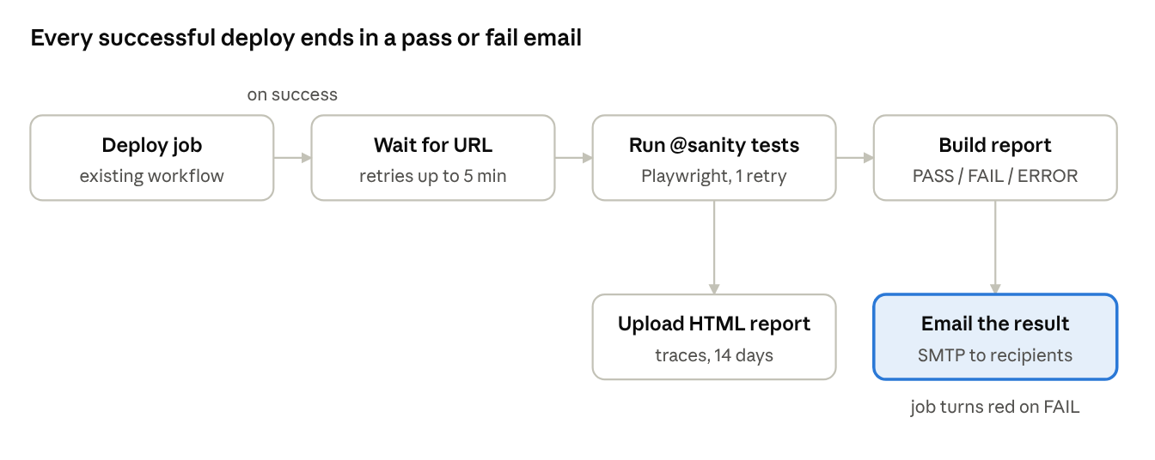
post-deploy sanity flow · GitHub Actions
The deploy workflow calls the sanity workflow as a follow-on job; the email always goes out, and the email links to the run where the full report lives.

Components delivered
Five files make up the starter kit (shared as qa-sanity-pipeline.zip), tested locally on both a PASS and a FAIL run.
File | What it does
.github/workflows/post-deploy-sanity.yml | Reusable workflow: waits for the app to be reachable, runs @sanity tests, uploads the report, emails the result, fails the job on FAIL
.github/workflows/deploy.example.yml | The 6-line sanity job to paste into the existing deploy workflow
playwright.config.ts | HTML + JSON reporters, 1 retry in CI, trace/screenshot/video on failure
tests/sanity/smoke.spec.ts | 4 starter checks: home page status, console errors, health endpoint, login
scripts/build-report.mjs | Converts Playwright JSON into the email subject, HTML body and GitHub job summary
Email subject format: ✅ [Sanity PASS] QA — 12/12 passed (a1b2c3d) or ❌ [Sanity FAIL] PROD — 10/12 passed, 2 failed. An ⚠️ ERROR status is sent when no results were produced.

Email delivery (decision needed)
The pipeline sends mail over plain SMTP, so any provider below works by setting the same four secrets — no code change. Recommendation: use the company Microsoft 365 or Google Workspace mailbox if IT allows SMTP; otherwise SendGrid or AWS SES.
Provider | SMTP_SERVER | Port | Credentials | Watch out for
Microsoft 365 | smtp.office365.com | 587 | Service mailbox + password | SMTP AUTH must be enabled on that mailbox by IT
Google Workspace | smtp.gmail.com | 465 | Account + App Password | Needs 2-step verification to create an App Password
SendGrid | smtp.sendgrid.net | 587 | apikey + API key | Verify the sender domain
AWS SES | email-smtp.<region>.amazonaws.com | 587 | SES SMTP credentials | Leave SES sandbox to email any address
Recommended: a dedicated sender such as qa-bot@culinarydigital.com rather than a personal mailbox.

Setup steps
About 30 minutes once SMTP credentials are available.
- Copy the starter files into the app repo, run npm install, commit package-lock.json.
- In GitHub → Settings → Environments, create each deploy target (dev, qa, staging, prod) and add the variable BASE_URL.
- In Settings → Secrets and variables → Actions, add:
  - Secrets: SMTP_SERVER, SMTP_PORT, SMTP_USERNAME, SMTP_PASSWORD; optional SANITY_USER, SANITY_PASSWORD
  - Variables: SANITY_EMAIL_RECIPIENTS (comma-separated), optional SANITY_EMAIL_FROM
  - Recipients can be overridden per environment, e.g. a wider list for prod.
- Add the sanity job to the deploy workflow with needs: deploy and secrets: inherit.
- Replace the starter tests with real critical-path checks, each tagged @sanity.
- Smoke-test: Actions → Post-Deploy Sanity → Run workflow → qa.
If the deploy workflow cannot be edited, uncomment the workflow_run trigger instead (and skip step 4).

Acceptance criteria
Milestone 1 is done when all of these hold on the qa environment:
- ☐ A deploy to qa triggers the sanity job automatically, with no manual step
- ☐ Every listed recipient gets an email within 10 minutes of deploy completion
- ☐ A passing run sends a ✅ PASS email with pass/fail/skip counts and a link to the run
- ☐ A deliberately broken test sends a ❌ FAIL email naming the failed test and its error
- ☐ An unreachable URL sends a FAIL or ⚠️ ERROR email, not silence
- ☐ The HTML report with traces/screenshots is downloadable from the run
- ☐ Adding a recipient needs only a variable change
- ☐ The @sanity suite runs in under 5 minutes

Next milestones and open questions
Possible next milestones
- M2: Slack/Teams alert on FAIL, and a pass/fail trend view across deploys
- M3: Block promotion to prod when staging sanity fails; optional auto-rollback
- M4: Wider regression suite on a nightly schedule
Open questions
- ☐ Which email provider and sender mailbox will IT approve?
- ☐ Do the QA tests live in the app repo or a separate QA repo? (A separate repo needs a repository_dispatch trigger.)
- ☐ Which environments get emails, and should prod go to a wider list?
- ☐ Which 5–10 user journeys define "sanity" for our product?
- ☐ Is a test account available for the login check in each environment?

